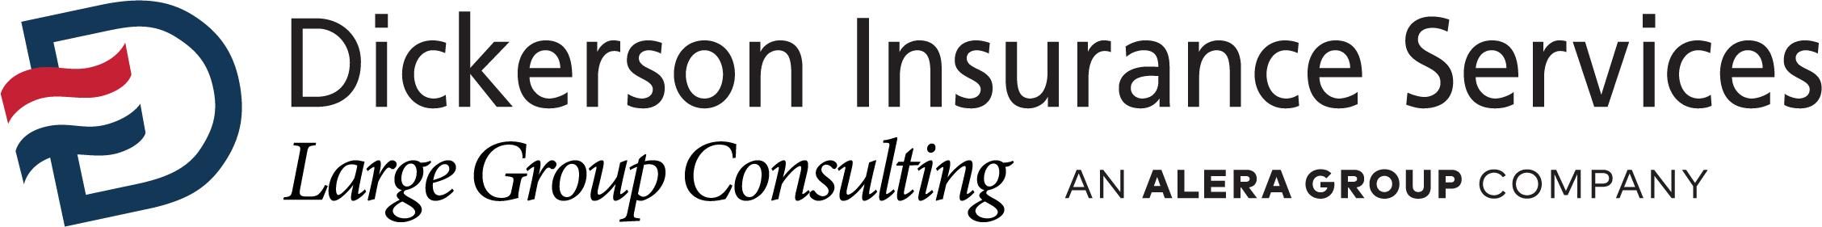

Job Description – Associate Account Manager

Classification: Salaried, Exempt
Department: Large Group Benefits Consulting
Supervisor: VP Account Management/Marketing Strategy
Work Location: Los Angeles, CA

Company Profile
Dickerson Employee Benefits was founded more than 50 years ago by Carl Dickerson. From this one-man operation, selling insurance door-to-door, the company has grown to include employee benefits, property and casualty insurance and consulting services among its offerings.

Today, the company is a partner firm of Alera Group. Alera Group offers industry expertise in insurance services and wealth management, combined with the ability for partner firms to preserve their company cultures, staffing and business models.

Dickerson Employee Benefits has deep roots in the minority and culturally diverse communities of California. The belief that all people should have equal access to affordable health care is still at the core of the business. From its headquarters near historic Dodger stadium, the company provides sales and service support throughout California and the United States.

Position Description/Summary
- Coordinate the Request for Proposal (RFP) process on behalf of a client.
- Collect, analyze and interpret data from vendors/carriers for reporting to the client, including cost projections and evaluation of vendor renewals.
- Gather health benefits data and comparing a client’s plan information to other companies by industry or geography.
- Review client needs recommend suitable approaches and help implement benefit program strategies.
- Model employee benefits contributions to meet employer objectives.
- Develop client communications, including proposals, reports, spreadsheets and presentations.
- Assist with employer-level client service needs
- Attend staff meetings, department and carrier meetings as well as educational workshops.
Customer Base
- Fellow Large Group Consulting Team Members, Dickerson Management, Carrier and Vendor Partners, Employer and Employee Clients
Minimum Qualifications
- 3+ years’ experience in customer service, proposal development or account management in an employee benefit setting. Experience working with large employers a plus.
- A bachelor’s degree or equivalent business experience with an emphasis in statistics, data analytics or finance.
- Intermediate level expertise in Microsoft Word, Excel and PowerPoint.
- Excellent organizational, and interpersonal, verbal and written communication skills.
- Strong attention to detail and ability to self-check work.
- Strong problem-solving skills.
- Current CA life and health insurance license or ability to obtain immediately.
- Agency management system experience preferred.

Key Qualifications/Skills
The ability to:
- Adhere to company policies, procedures and guidelines
- Deliver presentations with verbal clarity and confidence to both small and large groups of people
- Work in a self-directed manner
- Maintain confidential information
- Organize and manage multiple priorities
- Work well under time constraints presented by regular and frequent deadlines
- Work independently and as part of a team
- Represent Dickerson in a professional manner at internal/external meetings and events

Disclaimer

This job description in no way states or implies that these are the only duties to be performed by the employee(s) incumbent in this position. Employees will be required to follow any other job-related instructions and to perform any other job-related duties requested by any person authorized to give instructions or assignments. All duties and responsibilities are essential functions and requirements and are subject to possible modification to reasonably accommodate individuals with disabilities. To perform this job successfully, the incumbents will possess the skills, aptitudes and abilities to perform each duty proficiently. Some requirements may exclude individuals who pose a direct threat or significant risk to the health or safety of themselves or others. The requirements listed in this document are the minimum levels of knowledge, skills or abilities. This document does not create an employment contract, implied or otherwise, other than an "at will" relationship.

