Emily Santanelli

Vice President
USI Insurance Services, Inc

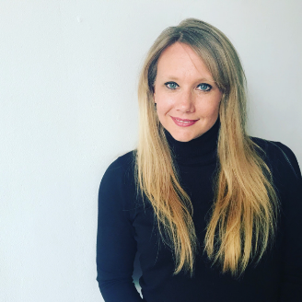 |  | Emily is a Vice President & Consultant in the Rancho Cordova, CA office. She has over a decade of experience in the wellness industry and employee benefits sphere. Her focus is on partnering with clients to help identify and implement long term cost control measures, along with health and wellness strategies and to help curb health care costs. Emily hopes to build long lasting, service-oriented relationships with each client, understanding their unique needs.  Emily earned her Bachelor of Science degree in Kinesiology from Texas A&M University. She spent ten years working at Cooper Aerobics Enterprises in Dallas, Texas focusing on wellness, consulting and forging long term relationships with community partners and businesses. After, Emily began her own wellness consulting company prior to joining USI.  Emily has a love of community involvement. She currently serves as the Vice President of Professional Development for Sacramento Area Human Resources Association (SAHRA). Emily is involved in her local church, schools and serves on the United Way California Capital Region Resource Development Committee. You will find her regularly speaking at HR Professional events, workshops and CFO roundtables as an industry expert.  Originally from St. Louis, Missouri, she and her husband, Vinny, now reside in Lincoln, California with their two children, their beloved German Shepherd and sassy cat.

